**Git initialization**

**Way 1:**

cd ~/nameOfFolder

git clone <Link> <folderName>

Example: git clone <Link> dev1

**Way 2:**

mkdir dev2

cd dev2

git init

git remote add <clone with SSH>

**To get the remote changes locally:**

git pull origin master

**To view all files in directory:**

ls -la

**To view history of commits:**  
git log

**To view configuration:**

git config --list

**To create a file:**

echo ‘Hello, World’ > hello.md

**To see the status(untracked):**

git status

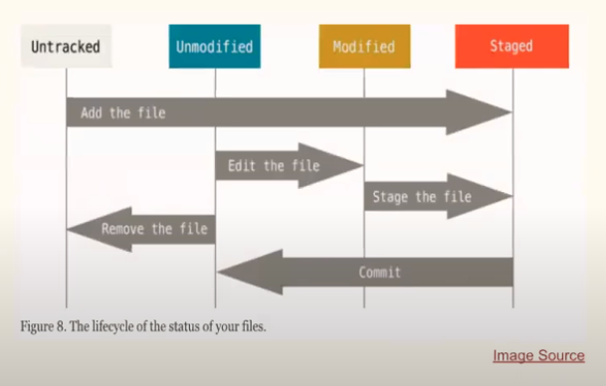

**To add the file: (Staged condition)**

git add hello.md

git add .

**To commit file:**

git commit -m ‘C1:master Add hello.md’ (-m is message)

**To view the changes occurred in the commit:**

git log -p <hash of the commit from “git log”>

**To commit to server:**

git push origin master(branch name)

**To view local branch:**

git branch

**To view remote or server branch:**

git branch -r

If we have minor changes which were an accident in the previous commit and we don't want to use another commit then we use the amend command.

git commit --amend -m ‘C1:master Add hello.md’

**To ignore certain files:**

nano .gitignore

//file names

node_modules

.DS_Store

**Create new local branch:**

git branch b1

**Use b1 branch:**

git checkout b1

**Toggle branch:**

git checkout -

**Shortcut to create a branch and toggle to that branch:**

git branch b11; git checkout b11

These 2 commands become:

git checkout -b b11

**Delete a branch:**

git branch -D b11

**Without committing if I want to save the progress:**

git stash save ‘more change’(give a message like commit)

git status returns a clean working directory.

git stash list

// go to other branch to complete other work.

==>Come back to the node b11 in which the incomplete work was done.

git stash apply

// if I want to apply other stash then copy from stash list:

git stash apply stash@{1}

**To delete stash:**

git stash drop stash@{1}

**To apply a stash and delete the stash:**

git stash pop

git fetch origin; git merge master -> git pull origin master